Nepal College of Information Technology
Balkumari Lalitpur
Assessment Exam Fall Semester 2008
Year: III Sem: I
Program: IT/CE Time: 3hrs
FM: 100 PM: 50

Numerical Method

1. a. Find a real root of the equation
x - x log x = 0.5
by N-R method, correct to 3 decimal place 7

b. Solve
Cosx = 3x - 1 by fix point iteration method 8

2. a. The following are data from the steam table:

Temperature(Tº C) | 140 | 150 | 160 | 170 | 180
Pressure Kgf/Cm² | 3.685 | 4.854 | 6.302 | 8.076 | 10.225

Find pressure of the steam when temperature is 142º & 175º.

b) Find the missing values from the following table

x | 16 | 18 | 20 | 22 | 24 | 26
y | 43 | 89 |  | 155 | 268 | 388

3. a. Evaluate 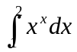 by using (i) Trapewzoid rule & (ii) Simpson's rule. (iii) Simpson's rule 8
b) Evaluate 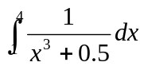 by Gausian 2 & 3 point formula 7

4. a. Solve 7
8x - 3y + 2z = 20
6x + 3y + 12z = 35
4x + 11y - z = 33
by an iteration method
b. Solve
x + y +z = 3
2x - 3y + 3z = 16
3x + y - z = 3
by a matrix factorization method. 8

5. a. Solve 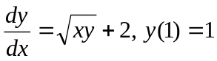 for y(2) taking h = 0.5 by Euler's method. 7
b. Solve 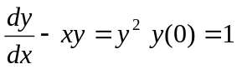for y(0.4) taking h = 0.2 by the method of Runge-Kutta 4th order. 8

6. a. Find largest eigen value & corresponding eigen vector of the matrix A = 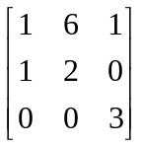 7
b. Solve 4x³ -e^{-x} -5 = 0 by bisection method 8

7. Write short notes on (Any two)
a. Convergence of Netwon-Raphson method
b. Gauss elimination method & Gauss Jordan method.
c. Solution of differential equation by Picards method.
d. Lagrange's interpolating polynomial.

